NAVIGATING THE SHARED BODY:
ACTING IN THE BALANCE
By

Patrick Lloyd Porter

© 2018 Patrick Lloyd Porter

A thesis
submitted in partial fulfillment
of the requirements for the degree of
Master of Fine Arts (Performance and Performance Studies)
School of Liberal Arts and Sciences
Pratt Institute

May 2018

©2018
PATRICK LLOYD PORTER
All Rights Reserved
Introduction

An Actor on the theatre stage is a performing artist who relies upon her own body as the instrument and medium, by and through which she portrays characters and interfaces with the world of the play. Actors use various techniques, acting theories, and creative tools––often acquired over years of training, practice, and experience––to consistently achieve their characters when required to do so over the course of a play's run. Could these performing artists all share some deep level of process?
The thesis concerns the following: (a) How we might understand theatre acting as a performance of a dynamic balancing of selves within a shared body as central to an actor's process and art of characterization. (This body, for the purposes of this paper, is expressed as a person or body––or person/body––standing in for the bodies of all persons who are actors in art and on stage, but who are also just like everyone else in daily life); and (b) A reconsideration of Richard Schechner’s theory of the actor's liminality––a paradigmatic articulation for liminality in acting performances (as well as the rehearsals that lead up to them) when differing selves, identities, or characters are navigated by the performers on stage (Schechner 1985, 123).
I conclude that a common dynamic balancing of Actor/Character can be located in all acting performance in the Western theatrical tradition. I also conclude that Schechner’s theory of actor's liminality does not go far enough to be inclusive of the practice of acting. I propose, instead, that liminality for the actor is not severable from the body and exists as a bodily process. This reconsideration situates the actor's liminality within the dynamic balancing of the actor's work in characterization.
In this discussion, I explore the acting process and performance in the Western theatrical tradition, by which I mean acting a character or role that interacts in any particular play. This play might be realistic, or non-realistic, or devised from rehearsals, or in a stylistic range from tragic to comedic in nature, but there should be an understanding that the requirements of plays in this discussion include that their characters act––in their core––human, not necessarily humanely, but within the reasonable realm of what would portray homo sapiens (even if playing a dog). For those who might decry plays where roles are closer to fragmented selves or even actual animals, I maintain this discussion can apply to particular circumstances in such works and remains pertinent.
For our purposes here, acting involves the actor and the character, and balancing these. I will address this balancing of entities through noticing ways in which acting (and indeed theatre) has been viewed, and where practice borrows or leaves these ideas behind.
Actor / Character
The first sentence of renowned British theatre director Peter Brook’s (1925–) book, The Empty Space, is often quoted: “I can take any empty space and call it a bare stage” (Brook 7). Less quoted is the second sentence: “A man walks across this empty space whilst someone else is watching him, and this is all that is needed for an act of theatre to be engaged” (Ibid.). Ultimately, to be theatre, it is the person of Brook's solitary figure who must appear and walk in the empty space/stage in front of that audience of one (or many). Neither Brook’s direction, as revolutionary as it may be, nor the playwright's words in all their brilliance, nor perhaps a literal copy of the printed text displayed in a deconstructed cleverness on the stage to ironically remind us that we are only texts, can tell us “This is theatre.” Nor can the costume, lighting, or set designer's designs, which might add tremendously to the storytelling and performance experience; no, not even the investors’ or producers’ money or experience, the existence of which enables the production to exist, makes theatre happen, whether alone or in combination. It must be at least a person walking, talking, living, portraying, and performing in that “empty space”––no longer empty––while witnessed by a separate audience body, either individual or group, that creates theater.
The formula of the theatre event on a stage in the Western tradition is quite simple, but the execution complex, especially from the point of view of performance. This solitary figure, the actor, carries with her an open secret. The audience has come to witness, indeed, has paid to witness this. The actor enters onto the stage in a shared body with that of her character or role. What the actor creates is indelibly tied to herself, yet experienced by the audience as the role. What does an actor do? What does it feel like, this shared body, from inside the actor? What does the instrument of the body contain that provides the material for the actor's art? How does the actor create a role? What does a role entail? How does the actor share a body?
The shared body is represented going forward as Actor/Character, symbolizing a depiction of its workings as a dynamic, active, and physical process and performance of balancing these two aspects or selves sharing the body of the person of the actor, again, the person/body for purposes of this discussion. The slash, or virgule, in the term Actor/Character serves several intentions as the virgule has several usages in the English language. The slash is intended for our purposes to indicate and, to indicate or, to represent a conflict, connection, or both between two things, to indicate a replacement for the Latin word cum, which stands in for language indicating a combination of things or equivalencies, or even identicalness (Penn). Additionally, the slash in the term Actor/Character serves as an indication of a fractional relationship, or ratio, of each term to the other (Penn). The slash’s importance lies not only in indicating (in text) the shared body, but also because it offers an understanding of a particular dynamic relationship between the two coexistent selves, entities, aspects, or ways of being for both Actor and the Character. This dynamic balancing, developed during rehearsals, happens in performance in front of an audience, in a single-bodied lone figure (which actually is not so alone as it is a shared body) walks out on stage, thereby constituting theatre. This balancing is the essential nature of acting performance.
The performance of a role or character, at its most basic, is as a dynamic reciprocation that seeks a regulation of balance between the Actor/Self and the Character/Self or role to be portrayed. This balancing act performs, in practice, as an inversely proportional relationship between Actor/Character. This dynamic, inversely proportional relationship is affected by the realities experienced during performance, a moment-to-moment progression through a script or theatrical work, including relating with other characters and the given circumstances––not only of the story, but of the concept and direction. Importantly, the circumstances and the entire process is directly affected by the actuality of the person/body, the body that is shared, the actor's instrument.
Many of the moments of performance have been solidified in rehearsal, when the Actor works in an increasingly specific and intense relationship to the circumstances of the theatrical world, provided by the play or devised work. The Actor, via his technical or strategic approach (for example, Stanislavski, American Method, Michael Chekhov, Adler, Hagen, Meisner, or Classical Acting base [Hodge]), begins to map out the character's journey over the course of the play, its emotional and physical life, its behavior in interaction with others and its environment. This map or performance score guides the performance and is the rehearsed and developed setting which enables the performance of dynamic reciprocating balance.
The actor's performance score [. . .] might best be thought of a tapestry of four interwoven layers, including: 1. the performance score for the production as a whole, that is, the dramaturgy and “general design” for what “the spectator sees,” tempo-rhythm and orchestration; 2. each individual actor's score consisting of the specific set of actions/tasks orchestrated rhythmically within the design of the whole; 3. the specific aesthetic logic or dramaturgy that informs an individual actor’s often idiosyncratic creation of that score; and 4. the extremely subtle elements and threads of associations, memories, feelings, sensations et cetera [of the Actor's personal] subscore. (Zarrilli 16-17)

This score, however, recorded/notated and embodied by the actor is a relative constant in the craft of acting. Whatever consistency or repeatability the score enables in the acting performance, the Actor/Character balancing remains dynamic and responsive to each inevitably different performance. As the Character/Self begins to increasingly dominate the concentration, focus, and awareness over the course of the play, the Actor/Self moves into the background.
However, unexpected things do happen in live performance, some of them less than desirable. Let another actor make an early entrance, or an actor forget his lines; the Actor aspect will rush back, relying on the technique, that always pulses underneath the actor's performance, ready to hold the space of illusion of character or fictional world while the actor works furiously to remember the line, or determine if the pages of dialogue skipped by that early entrance can be left behind without leaving the audience lost in the story.
It is interesting to consider that the Actor/Character can never be totally one entity or the other; there remains in the best of circumstances only the illusion of total melding of the Actor into the Character as an attainable goal for the acting artist. As I discuss below, in these moments of close approach to the character, the Character/self might bypass the Actor/self. It is physically impossible to transmute into another, different body and being. In a manner of speaking, the shared body is the ultimate fiction the actor contends within the theatrical world, the actuality of a person/body playing in a fictional world toward a fictional character (with its own distinct body) and accepting that they both are reality, in distinct and simultaneous existence. The actor's goal is to fully embody the “other,” either by living the part inside-out or playing the part outside-in for the belief of the audience. Perhaps more interesting is the notion that the actor cannot even play himself, no matter the closeness of the role to the actor's person, personality, or biography, even if the role is the actor himself (Hornby 87).
See / Saw
Acting as a dynamic balancing of Actor/Character can be illustrated using the common image of the see/saw [sic.]. A good way to demonstrate this idea is to apply the concept of adding weight to the Actor or Character sides of the see/saw via the notions of similarity and difference between a person taking on an acting role in a play (the Actor/self) and a person in the role to be embodied (the Character/self).
Figure 1 illustrates an ideal balance between Actor and Character. When the Actor (A) Balances (B) with the Character (C), the energy is focused and concentrated within the balance point, the slash, and abstracted see/saw, Actor/Character. To achieve this balance is the goal, but as experienced this is more of an indication point that the actor is in a special alignment: moment-to-moment, flow state, dual awareness, and so forth. During this ideal balance, the actor might also sense a peripheral experience wherein, inside of the Character, the Actor/self falls away or is bypassed and the Character/self draws upon the person/body of the actor rather than the Actor(performer)/self. When this happens the Character––not the Actor––is acting using the body of the person.
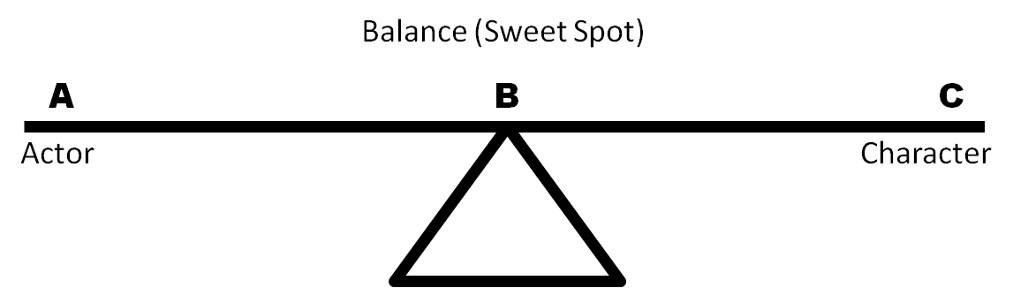
Figure 1. See/saw dynamic balancing of Actor/Character (sweet spot).
Should an actor working on a character or role find a predominance of similarities with the role she is to embody (Figure 2), the weight of the see/saw leans toward the Character. Her work or focus is toward differentiating herself to fit into the fictional world of the play. Although similar to the Person/body, the character is a totally different person, aspect, role than she will play. Difference between the Person/body and the character is always a fundamental experience for the actor; even in a devising situation, which lines up most commonly with a similarity-predominant situation. There will always be work on the actor's part to build on the differences between herself and the character in order to get the balance right or close enough and thereby approach the Character credibly enough in the performance to engage the audience.
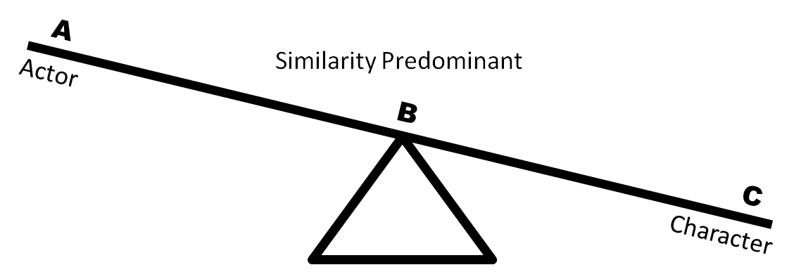
Figure 2. See/saw weighted toward a predominance of similarities between Actor/Person and character.
One might think, looking at Figure 2, that if the person of the actor shares many similarities to her assigned role or character, the see/saw would be illustrated as weighted toward the Actor side (i.e., the Actor would show as the heavier weight). However, in such cases it is important to remember that when the actor begins to work on a part in these similarity-predominant circumstances, the character, as very similar to the actor, is already weighted heavier because the actor's work has theoretically already been done, at least in part, simply because of their similarities. Therefore, relative to the character/role creation process, the actor must navigate the similarities to find differentiation, and therefore to emphasize their differences. To reiterate illustratively, in Figure 2 the character is largely determined by similarity to the person of the actor, or the person/body, as the character is already grounded in aspects of the actor/person’s daily self, personality traits or an energetic aspect, or even physical resemblance, for example.
By contrast, let’s say the actor works on a role with a predominance of differences between herself and the character (see Figure 3). As the character is always different to some extent from the person of the actor, differences need to be understood and incorporated into and onto the actor's body in order to portray a role that is significantly different from him. Thus under the circumstances of a predominance of difference, the see/saw leans towards the Actor side. The Actor is obliged to embody those differences by creating them, or manifesting them through more radical embodiment, as expressed in the Character's psychology or physicality, for example (although both of these are inseparable from the body). This has the effect of adding weight to the Character's side of the see/saw and moving toward balance, as the Actor or performer is giving up or sublimating certain elements or aspects of his personality, and trading them, during the moments of the play, to take on and add different aspects of (an)other.
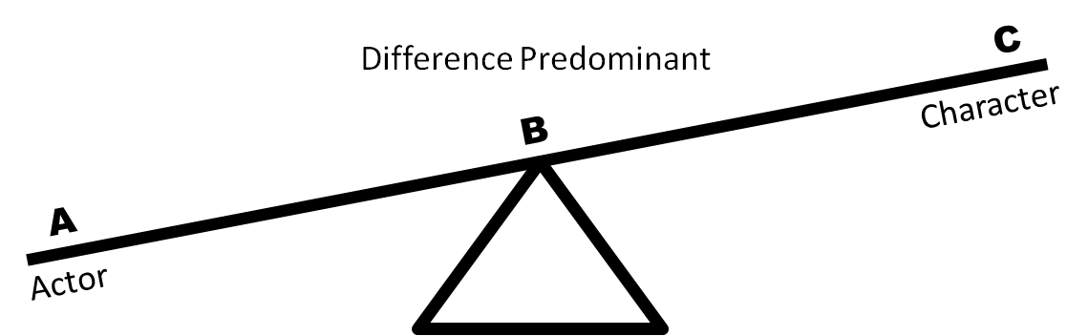
Figure 3. See/saw weighted toward a predominance of differences between Actor and Character.

Ultimately, pursuing the embodiment of differences of the Character from the Actor helps to achieve an optimal balance, to activate the sweet spot in the performance of the Actor/Character balance, and––for what are usually rare moments within the performance––attain some level of inspired performing. What is important to remember is that a performance runs on the steadiness of technique, experience, and energy of the performers. The sweet spot speaks to the actor's aspirations on stage, those moments of true inspiration. The balance is dynamic, not set. The performance is in the balancing, the adjusting, affected by other characters and exigencies on a particular night, the inputs and sensations that come to the actor's body––a teeter-tottering, if you will (for example, that lady crackling her candy on the first row, the cell-phone, the chattering, or the reactions or lack thereof, i.e., the audience).
So, what occurs in the balance, the sweet spot, when (as mentioned before) the slash in Actor/Character would seem to disappear? In this spot the Character no longer considers the Actor/(performer) Self; rather, shifting occurs from between Character/Self and Actor/(performer) Self in the interplay of balance, to a movement in a more direct energetic exchange between Character and the body of the actor (person/body). (The body is the common denominator across all the selves/identities involved: person/body, actor/body, and actor/character/body). Thus, the Character lives through the bodily reality of the person/body, and the person lives through the performance of and by the Character. The Character becomes the actor/performer in respect to the Person of the Body, bypassing the direct action of input from the Actor/(performer) self. The Character, not the Actor, acts.
Free of a directly discerned, performing Actor/self, the “subject“ of the person/body experiences the object of the created Character/self. The character (via the Character/Self) performs its life or role in the fictional world of the play, balanced in the shared body of the Actor and Character selves, yet energetically connecting to the grounding of the person/body, through the sweet spot of ideal balancing. The Character is now performing and no longer needs the same input from the Actor or separate performance/self to energize the performance (except when something goes awry). Or, more likely, in the pursuit of an ideal balancing, the Actor is needed, in the moments that are not in balance, to steer the Actor/Character, via the score and technique through to a credible performance. When those moments of Balance occur, redundancy disappears and the Character/Self can bypass the Actor/Self in the dynamic reciprocation.
This is the goal of inspired acting; it is also the point where dual awareness is possible, when the person acting gets the sense of watching himself perform with ease. More specifically, this is the point where the Character adopts the person/body’s stored acting technique, knowledge, livability, and so on, without an active performance energy from the Actor/Self. The biography or personality of the everyday person/body is not active in these instances. Rather, it is as if the Character draws on its own memory to fill its emotional life, akin to an emotion or affective memory exercise, well known in the training in the American Method, based on the early work of Stanislavski. This inspired state might thus be labeled “method acting of (by) the Character.” Thus, as a person lives, a character lives via a shared body. A character only lives in performance and by performance (specifically demonstrated here as a dynamic balancing act of inversely proportionally reciprocating selves). A character's “living” is acting.
Liminal Play/Ground
We might usefully view this dynamic balancing of the actor as a liminal zone. Richard Schechner worked toward an articulation in performance with the following:
I propose a theory that includes the ontogenesis of individuals, the social action of ritual, and the symbolic, even fictive, action of art. Clearly these overlap: their underlying process is identical. A performance “takes place” in the “not me ... not not me” between performers; between performers and texts; between performers, texts, and environment; between performers, texts, environment, and audience. . . . The antistructure that is performance swells until it threatens to burst. The trick is to extend it to the bursting point but no further. It is the ambition of all performances to expand this field until it includes all beings, things, and relations. This can't happen. The field is precarious because it is subjunctive, liminal, transitional: it rests not on how things are but on how things are not; its existence depends on agreements kept among all participants, including the audience. The field is the embodiment of potential, of the virtual, the imaginative, the fictive, the negative, the not not. The larger it gets, the more it thrills, but the more doubt and anxiety it evokes, too. . . . The spectators do not “willingly suspend disbelief.” They believe and disbelieve at the same time. This is theater's chief delight. The show is real and not real at the same time. This is true for performers as well as spectators and accounts for that special absorption the stage engenders in those who step onto it or gather around it. Sacred a stage may or may not be, special it always is. (Schechner, “Between Theater” 113; my emphasis) )

This Not Me–Not Not Me (NM–NNM) liminal zone derives from a duality of time, considered in Schechner's ontology of performance, to which he ascribes restoration of behavior as a main characteristic or indicator (Schechner, “Performance” 28-29). Whereas Schechner is theorizing commonalities in the shared “underlying process” of among those quoted above, ritual and theatre, this discussion refers to the NM-NNM only to the extent of acting performances on the stage.
Performance is an event of restored behavior, a variation of behavior that has happened in the past and is used in the present. “Restored behavior is the key process of every kind of performance,” and might be seen as strips of behavior whose origins are lost, but available to be reconfigured and reordered to create a present behavior or, rather, performance (Ibid. 34). Carlson qualifies this notion by pointing out that performance requires a conscious nature of such behavior: a knowing that the behavior is being behaved, and that it is for the “benefit” of someone else (i.e., the behavior is knowingly performed for someone––even the self (Carlson 5).
Schechner describes restored behavior as “me behaving as if I were someone else” (Schechner, “Performance” 34), an articulation of performance, equivalent, on a general level to a broad description of acting: a coexistence of multiple generators of behavior––the person behaving (person/body), restoring past behavior in a balancing of behaviors that is itself a restored behavior (Actor/Character). This “new” performance then, of course, becomes part of the repertoire of behaving to be restored by future performances, and so on.
In theatre, Schechner places an actor's liminality in the various phases of his theatre-making performance process, ultimately landing on liminality as inclusive of workshops, rehearsals, and performances (Schechner, “Between Theater” 99-100). He continues to articulate the anti-structural nature of this zone as akin to an oscillation, or back and forth, between the character (Not Me) and the actor (Not Not Me; 111-12).
For Schechner, the actor inhabits a creative temporality (rehearsal or performance), which is liminal per se, during which she works out how the character manifests in relationship to herself (rehearsal), or she invests her energy into that active established behavioral patterning/balance (which she created in rehearsal), to restore it in the performance. Does this mean that performance is a mere reproduction of rehearsal? No. The performance shares the liminal double negative found in rehearsal because the performance(s) in reality become reiterations and reconfigurings of restored behaviors––the audience, the interactions, the discoveries that occur in performance are always different and always happening each time the play plays. Performance, although rehearsed, is still an active balancing of Actor/Character within a layered liminality of the actor's work. It finds the inspired balance of Actor/Character with the production's progression toward a larger Not Me––that of the play’s fiction––presented as embodied reality (the bodies are real, even if the play is non-realistic, as is the performance “real”), Schechner’s theory of the double negative nature of performance pertaining to acting is progressive, processual, not temporally based and scheduled.
Reconsidered as a progression toward the Not Me, Schechner's actor's liminality can be expressed as moving into and through Not Not Me to approach the Not Me, reversing his terms, yet preserving a double negative precept of performance liminality. The Actor can understand his personal process/acting approach as consistent with an articulation of theory. The Not Not Me is now a “pass through” toward a transformative goal, the Not Me. In this it presents in practice a process in and of itself, which, in acting in particular, is a progression of approach toward character.
In the moment of inspired acting, another way to picture this liminality, is as a cycle. The Not Not Me (the domain of the Actor) fades, or is bypassed, in favor of the constant body of the person/actor. This concept parallels the liminal phases in ritual practices, distinguishing between initiatory or cultural rituals and those that merely transport (rather than transform) the participants of the ritual. These transporting events include theatre and acting performances. Thus, these aesthetic performances occur in liminoid zones and spaces that Schechner labels with the double negative.
In developing his theory of double negativity, Schechner drew on John Keats’ remark in a letter to his brothers, about the quality of “negative capability” as inspiration. However, rather than a liminal space with attendant structural subversion and community aspects, Keats saw negative capability as a quality that poets should obtain and follow as a way of life, accepting the mysterious and non-answerable rather than endlessly pursuing knowledge to figure things out. Negative capability referred to the talent or rather the character trait of not needing to know everything––to let mystery lie and work as it should (presumably, mysteriously). So Keats’ concept may not be the most analogous articulation of a double negative; however, this state of mind, or psychological situatedness, places the liminal as an embracing of mystery and has a faith-like adherence to unconscious or unperceivable occurrences. It also locates Schechner's thinking around the actor's liminality clearly in the mind.
Schechner uses examples of acting, and specifically character acting, to demonstrate this double negative liminal zone, in which the antistructure and communitas of ritual practices manifest analogously in acting/performances in general.
Actors [. . .] all train, practice, and/or rehearse in order to temporarily “leave themselves” and be fully “in” whatever they are performing. In theatre, actors onstage do more than pretend. The actors live a double negative while performing, actors are not themselves, nor are they the characters. Theatrical role-playing takes place between “not me . . . not not me.” The actress is not Ophelia, but she is not not Ophelia; the actress is not Paula Murray Cole, but she is not not Paula Murray Cole. She performs in a highly charged in-between space-time, a liminal space-time. (“Performance” 72)

Interestingly, this zone of liminality neither accounts for an actual limen, or entrance place where the person of the actor is made available to be changed (a threshold). This is plain from Schechner’s perspective. He avoids this liminoid area of the workshop/rehearsal/performance from the actor’s point of view; rather, he views it from the director’s perch. His Not Me . . . Not Not Me is a zone of creativity, if you will, where the actors, directed in their rehearsal, or when onstage, magically enter a temporal field to figure out or perform their roles/characters, not as themselves or any self, but as “performers” imbued, presumably, under a ritual-like ambrosial (anti)structure, provided by the director during the workshop/rehearsal––again akin to transformative ritual practices. How this temporal field forms, or how an actor’s transformation (or transportation) beyond her-self occurs, Schechner fails to address. Significantly, his theory stays rooted in the thinking about it, spun out of the reportage of his experience as a director. He also leaves us to forge the practice of his theory. Can Performance Studies be a practical tool for acting performance beyond the dramaturgical?
Where has Schechner hidden the body of the actor (the actual flesh entity that breathes life into the multiple aspects of Person/body, Actor/body, Character/body)? The body is the person. The Actor is always Paula Murray Cole. The character is never Paula Murray Cole. The Character is the actor’s goal and aspiration of her art, created by her talent and preparation in rehearsals/performance to dynamically balance the propensities of the shared body in favor of the Character. The Character shares the performing self of the Actor, such that the performing self (Actor/body) can step aside or be bypassed to allow the Character to do the acting in the shared body, unmediated or less mediated by the additional performing self of the Actor/body.
Where is the transformation that takes place when the person “crosses the threshold” into the rehearsal space? (And is that space geophysical or mentally produced in the bodymind? Or both?) Where is the rehearsal space? And what constitutes rehearsal?––Where and when is this liminal zone? How can an actor benefit by using Schechner’s ideas?
Given all that the actor is “doing,” this problem of the body––or rather, the answer/actuality of the body––must be addressed. In his description of the actor’s liminality, Schechner seems to dwell in the mental spaces and disappearance of selves, but this falls short in practice. How can liminality help/allow the actor to gain access to the Not Me . . . Not Not Me zone? Where is the limen located for the actor who is a persona with a body? Where does the person/body step into the Actor/body? Where is the artist's agency?
I suggest that liminality must follow the body, and that it is inseparable from it. Liminality, then, might be viewed as an evolved potential in every human; it is not severable from the body, and involves desire and choice: agency. If the actor begins acting out the role during personal study time with the script, weeks before rehearsals begin, in the privacy of her living room––is this not rehearsal? The actor decides the when and where of the threshold (limen) and the crossing of it. To open the definitions of what, when, and where rehearsal is or can be is to expand Schechner’s NM–NNM zone immeasurably, accounting for an extended notion of the liminal potential of the body.
Thus, to extrapolate from the person rehearsing informally, The person is the body when the threshold is crossed (into workshop/rehearsal––whenever that is––or into Performance). A performance self becomes foregrounded: the Actor. The process that then ensues is an approach to Schechner’s Not Me through the Not Not Me, via a process or progression, rather than a theoretical and psychological state of mind, loosely set in a structured workshop, rehearsal, or performance––as these might be understood in a theatre context.
Can the actor ever transform completely into the Not Me? The Not Me, presented as the first precept in Schechner’s liminal space of the performing actor, really makes little sense in light of the ordinary meanings of “Not” and “Me.” The Actor is a performing self here, using the body of his person/body, all that knowledge, memory, and the fail-safes and techniques the body holds as referent and as instrument. The person/body tethers the person, Actor/(performance) self, Actor/Character (and ultimately a predominate Character/self) to the body’s actuality.
To be completely Not Me is not possible, physically or mentally––even in trance. Why? Because the body and mind are not separate entities; one is contained within the other, yet separate and distinct. Humans cannot transmute into a different genetic body. From the actor’s point of view, this liminal zone exists as a process and progression of the Actor (performing self) rehearsing with the techniques and particular acting methods she uses (as perceived, comprehended, and communicated by her body) into the Not Not Me, toward the impossibly attainable Not Me. The Not Me exists theoretically as an infinity, and the Actor/Self moves more and more into the background in the balancing, inversely, as the character (the Not Me) is approached via the Character/Self. Thus, the Character/Self begins to predominate, through the techniques and tools of the Actor (both of these held as memory and knowledge) in the body of the person, that body, existing in time and space, as the person/body.
For the actor working toward characterization to consider that to say “I am Not myself” at the same time as “I am Not Not myself,” limits liminal power of the double negative within performance (not to mention rehearsals). The Actor as a performing self always moves into the Not Not Me. The Actor in rehearsal always moves and works through the Not Not Me using her techniques, training, and experience by developing the dynamic Actor/Character balancing required; thereby she enables an approach to character, a process of sublimating the Actor's biography in favor of the Character/Self body, which is a pursuit or approach to the Not Me. The person shares a body; this keeps the actor, the person she is, yet she surrenders her biography and physicality to performance selves in a dynamic balancing act (Actor/Character), which expresses itself differently from the person/body of the actor. The result is received as a layered, multi-dimensional Character/Self. The liminality of the actor functions at the bodily level and is engaged when the person/body moves into a performance self, instigated at the limen of rehearsal.
Thus, to comprehend the process of acting a character, Schechner’s notion of the actor’s liminal zone as a temporal, psychological state––or range of identity existing as “’tak[ing] place’ in the ‘not me . . . not not me’ between performers” must be expanded and restated to a notion of progression from the person (Person/body) to the person-performing (Actor/body) to the person performing a balancing (Actor/Character), existing as moving into and through the Not Not Me toward the Not Me.. This progression, can then be comprehended as an approach to character, a structure or map to be followed. By placing the Person/Actor into the progression at the double negative, the articulation of antistructure theoretically inherent in liminality, is maintained as the shared body and also matches the logic of finding and performing the Actor/Character balance by analyzing and discovering the similarities and differences shared by the person and the character. Otherwise, this creative zone of workshop/rehearsal into performance remains a distant, outside point of view of one overlooking (overseeing) the actor's work. Without the notion of progression, the actor is limited by Schechner’s mental geography of characterization as, at most, a general equivalency, proportionally equating actor and character (persona acting).
In an engaged progressive rehearsal process, the actor does not simply give the director what he wants; rather, the actor solves the problem of what is perceived as the direction by approaching the character or role (the Not Me). She does this by including the director's input and concepts into the circumstances of the theatrical world. In ritual, the liminal is a space of antistructure that enables transformation to take place for the initiates, the participants in the transformation. In theatre performance, actors inhabit an antistructure fundamentally different from initiatory rites, yet similar in a temporary way: antistructure is a process of transformation in the fictional world of the play.
Method / Character
There are innumerable strategies or techniques, or schools of acting. However, all still involve dynamic balancing as I discussed previously. These can be roughly divided into two very general schools of thought where creating a character or role is concerned: inside-out or outside-in (Zamir 13-14).
Inside-out actors focus on emotional verisimilitude in the performance. They base their roles on emotional truth by lining up their own personal emotional experiences analogously to those of the character. They work from an inner truth of the self, and layer structure on top of that inner foundation, building the character from the inside out (Ibid.). Outside-in actors primarily work from the imagined objective (from the script) characteristics of a role, such as physicality, voice, and intentions and actions of the role, gleaned from interactions and the circumstances of the theatrical world. From this foundation, these actors layer inward toward a potential emotional life, calculated to emerge organically from the effects of the externals (Ibid.).
Both inside-out and outside-in actors work from an analysis of the script, which can mean weeks at the table, or on-the-feet improvisation: the inside-out actor figures motivations and structure for emotional expression. This leads her to character intentions and objectives; the outside-in actor looks for clues about the character or role they are playing, in order to understand the role’s objectives and intentions in the story of the play (Ibid.). In the United States, this distinction, perpetuated and pronounced between the competing approaches of classical acting and method acting, remains quite strong, especially in actor conservatory or university training. Classical acting is most associated with the British actor tradition and training, emphasizing technical precision, physical mastery of the actor's body, and the engagement of a character's actions as foundational to characterization––the outside-in folks mentioned above (Rodriguez). Method acting––in its most pure form most associated with Lee Strasberg’s interpretation of Stanislavsky's early work, focusing on “living the part” by really experiencing true emotions using sense and emotion memory (as foundational techniques to engage the emotional life of the character)––is the inside-out camp (Ibid.). These broad descriptions are expressed in numerous dichotomies in addition to the outside-in/inside-out trope; for example, internal/external, experiencers/projectors, the emotional/physical, the true/pretend, and so on.
I view these dichotomous actor techniques as “false distinctions” because, in asking actors about this, they usually give a skeptical-looking smirk. In practice, or where the rubber meets the road of performance, these approaches tend to cross-pollinate and, in speaking to actors, they tell of doing a little of both. (For example, the actress, Ellen Burstyn, who worked with Strasberg and Adler has stated: “Stella stresses imagination and Lee stresses reality. You use Stella's imagination to get to Lee's reality. They are finally talking about the same thing” [Flint B10].) This makes sense, given the common denominator of the interface of the Actor/Character: the actor's body. Yet, the divide continues among actors, and those that train them, probably because distinct methods can claim their stars and their paths as the answer for all those seeking a way to a career. (Or, more mundanely, because of the idea that finding the answers they seek might make them a star.) In the workplace of the rehearsal room, or the green room during performance, however, there is little talk of technique or the particular approach an actor uses in their work. So much of acting is the doing, the experience, and the knowledge gained from being on the job.
Because technique enables a propensity for continuity and a specific means of using the bodymind to affect itself and others, technique manifests on two levels within the bodymind of the stage actor: as an “Ostinato of the Actor,” and as a “Body Instrument” for the Character.
How does the Character act when the actuality of the character is that of a three-dimensional idea, written out on a two-dimensional page? As the Actor's consciousness lets go, so that the character/role predominates in the body (and for the audience), the Actor begins to assume an important autonomic “safety valve” function, pulsing like an ostinato, a “motif or phrase that persistently repeats in the same musical voice,” which “plays an important part in improvised music (rock and jazz), in which it is often referred to as a riff or a vamp” (Chaz 59). As such, in the collaborative relationship of the Actor/Character, the Actor supports the orchestrated dynamic balancing in the acting performance, emerging to support the continuity of the characterization and the action of the play. As the Actor recedes in awareness in the body, the Character advances in focus and is foregrounded in the Person/body’s awareness, and “acts” using the techniques of the actor, which are stored and accessed in the body that is shared among Person, performance self (Actor), and Character (also a performance self) within its own life of the role.
For example, Tom Wingfield, in Tennessee Williams’ The Glass Menagerie, remembers and relives the memories of his childhood and young adulthood in St. Louis. These circumstances are supplemented with the emotional and physical events extrapolated from the circumstances of the theatrical world he inhabits: words and details from the dialogue and script, directional concept, design, and, most importantly, other characters and his interactions and relationships with them. When/if during the performance of Tom, which is a performance of pursuing the balance for Actor/Character, the balance is found (and ideally held as long as possible) the role of Tom (Character/self) bypasses the Actor/(performer) self’s conscious analytical mental processes and utilizes the Person/body, or the embodied (bodymind’s) knowledge and tools (including acting techniques), as Tom's (Character/self's) own (body instrument), adjusting his (Tom's) body and actions; this is a dynamic balance. This also indicates the Character is acting. The Actor/self is very present, perhaps even watching this, or in an active dialogue with Tom. Tom uses the shared body's embodied mind/brain to think and act Tom. Tom doesn’t think about Shreveport, LA (or the actor's personal hometown) and escaping from there, but of St. Louis, and how he is imprisoned by his family and work life. At the same time, the Character/Self doesn’t run an analogous script, thinking about Shreveport and escaping from there, to fill Tom with a corresponding emotional life that might be perceived as true, or make sense to the audience.
Tom's memory is the play, but Tom needs the Person/body’s know-how of accessing memory and emotion to use those emotional triggers, or rather be triggered by Tom's intra-play reality (which is a total fiction, of course). Of course, the Person/body provides the living structure through which the character Tom moves and speaks. The technique, talent, and rehearsal keep the biography and personality of the Person/body from entering the characterization. But the body cannot be ignored; the person of the actor is and will always be there, accounting for the autonomic systems of the body. The Actor/Self will always be there as the balance is lost, sought, and found in the teeter-tottering of the fluctuating performance. This phenomenon is akin to receiving computer assistance from a remote technician. We can always turn off Wi-Fi or “x” out of the connection to take back control (from the Character/self), but instead we allow the technician to do the work (the Actor is bypassed, steps aside, and the Character acts).
The importance of technique, then, is not only for the Actor to use it, but also to prepare for the Character/Self to use that technique. Although the Actor, of course, learns the technique, this provides the operational knowledge material for the Character when in the performing relationship of Actor/Character. If the Actor has no training in a particular technique, or is not talented in a natural imaginative world-making way of play, how can a dynamic balancing relationship be mustered, much less a balance be struck? In these circumstances, there is effectively no characterization or shift beyond that of what happens when in everyday life when one finds oneself in a situation of having to perform for others. The character would be consigned to the personal life of the (non)actor to animate as itself, cursing it by confining it to a performance of the everyday perfunctory self, without the know-how to moment-by-moment magnify and activate that self to fulfill a play script. In this case the Character exists purely as a name substituted for the actor, resulting in perfunctory role-playing.
No matter if the acting technique or theory followed is called inside/out or outside/in, internal or external, American or British, it aims for its own version of what is called theatre truth. Balancing inversely proportional dynamics of Actor/Character still occurs; it happens in the shared body. So, the actor might usefully conceive the ultimate goal not as playing the role, but contemplating how she can facilitate the Character’s acting. The role is bigger than the sum of its parts as the actor (as a performing self) plus the Person/body. The Actor finds her way to what works for her.
Balance / Zone
An underlying structure of the performance emerges through rehearsal, part and parcel of what an actor does. In performance, this antistructure exists in the moment-to-moment play, as the character predominates and interacts with other actors or characters in the play, who are also involved in their own dynamic Actor/Character balancing acts. This antistructure lies in the approach to the Not Me, and here we locate the sweet spot, where the Actor/Character balances in harmony with the circumstances of the comprehensive world of the play: script, direction, design elements, interactions of the characters, and the audience, and so on.
If the performance is engaging and credible, the audience completes a mental picture of the person/body as the Character, synthesizing the information coming to them from the stage, setting their discernment firmly in terms of the fictional world really embodied in front of them. The audience ultimately fulfills an actor's transformation into the Not Me of the character.
The process of balancing between Actor/Character requires rehearsal, and happens over time by using the Actor's tools with the collaborative context of the preparation, process, and performance that makes theatre. Getting the balance right is the goal (which sometimes never quite happens). To use this double negativity as a zone is helpful from an objective standpoint, or for study by the Director, but for the Actor in process of balancing with the Character, this requires experiencing (within that realm) the possibilities that the liminal makes available. Hence, liminality can work for the actor if she views it as a progression.
In rehearsals, the actor is traveling within the liminal zone, from point A (the limen, where the disequilibrium begins) to Point B (the equilibrium), a point of a readiness to perform as the character. Given the nature of performance and the paradigmatic relationship of performance and the liminal as Schechner proposes it, the equilibrium is not a static point. The liminal and performance are analogous and, for the purpose of discussion, the same zone; thus the Character performs in the liminal zone and the final curtain ends the liminality and the performance.
The subjective viewpoint of the actor is one of a progression, respectively, on the smaller and the macro scales of rehearsals and performance. This progression within this context of Schechner's double negativity, progresses into, through, and from the Not Not Me toward the Not Me. To consider this liminal state an actual space of progression, change, or transformation, rather than a mere psychological state of being, finally brings Schechner’s double negative concept into alignment with practice. Temporality (or time) and progression comprehend the body and the unity of the bodymind. Progression also aligns this liminal zone, with its characteristics of deconstruction and reconfiguration, as part and parcel to the ritual process as the larger scheme of Victor Turner’s (1982) theory of social/aesthetic drama.
Those tools, used by the actor to find the sweet spot of balance in the Actor/Character, must connect through the body in progression, not merely through thought or analysis. If the Actor has a body, the double negative of the liminal––where the balancing toward character takes place––must be conceptualized as both zonal and progressive.
The IN
For the actor to find the balance between Actor/Character, a strategy called the “IN” provides an answer. In her introduction to her play, Fires in the Mirror: Crown Heights Brooklyn and Other Identities, Anna Deavere Smith articulates her discovery of her now renowned process of interview and reenactment around historical happenings of polarizing racial/ethnic conflict in the United States (Smith xxiii–xii). Her interviews are strategies not only to collect the material words of people involved directly or indirectly, or a part of the community affected by an event, but also the extra-linguistic material and physicality of those interviewed as a treasure trove. This trove she uses for her masterly imitations, down to the exacting detail she performs. Although this strategy involves drawing from live personae, as opposed to written characters, Smith illustrates an important strategy in the Actor/Character balance, that of the IN. How does the actor get inside the character, or get insight into a role? How does one start this balancing act? For Smith, this appears as the voice, the physicality around the speaking voice, perhaps a revealing gesture or, most emphatically, what is said:
Speaking teaches us what our natural “literature” is. In fact, everyone, in a given amount of time, will say something that is like poetry. The process of getting to that poetic moment is where “character” lives. If I were to reiterate a person’s pursuit of that poetic moment, as well as the poetic moment itself, I could “go into character.” [. . .] Character lives in the linguistic road as well as the destination. (Smith xxxi–xxxii)

Smith's interview strategy suggests that if you allow people to speak long enough, they reveal themselves, not only by the physical nature of their speaking, but by those moments expressing an inner depth (xxxii). This is the IN; and it provides the balance point in my see/saw, the fulcrum of the process. The IN is the beginning point of entry into the plane upon which the Actor/Character resides. It is encompassed in the slash that separates and unites them. The IN is also a subjective indicator for the actor to identify and build around, whether a physical or psychological mark. Indeed, the IN might change in specificity or expression, or the actor may discover another stronger indicator. The IN is not only a motivating component of the character. But acting is about action, and impetus for action in the story can be broadly applicable to a character.
The character’s or the role’s IN must be a part of the circumstances of the play. In fact, the given circumstances are foundational with any theatrical production. Whether specified in the play or given by the production concept, a character lives in that world. Anything that can be reasonably extrapolated for the character in those circumstances is fair game for the IN.
The IN can be obvious, as in patent, seeable, discoverable, such as anything said by or about a character. It can be gleaned circumstantially by considering the actions of the character and what the playwright has them do, or what the composer has them sing. Small rebellious actions, which insignificantly disrupt the character’s quotidian existence (even if this act would signify this rebellion only to themselves), are strong indices of a character's inner world or thoughts. Is there a special object with a powerful sentimental hold that connects to aspirations or promises the character made to someone or to herself?
The IN can present itself forthrightly, or at a time when the actor makes a connection through her costume, or in physical choices that reveal an unstated insight. Whatever it is that the actor considers the IN, she must recognize its importance as a point, or the slash, that holds the Actor and Character together. As the fulcrum in the balancing of Actor/Character, the IN, for the actor, is the point of departure into the character. As such, the IN functions as the point of connection in the Actor/Character balancing, and ultimately the connection to the person/body.
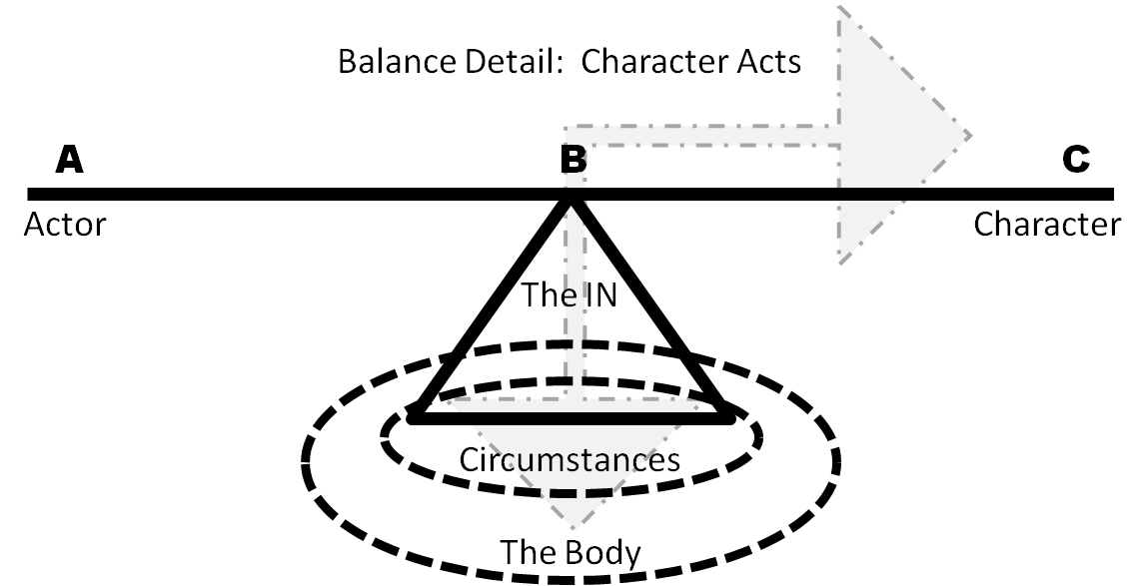
Figure 4. When the character acts (lives): the goal.
Conclusion
With the fulcrum as lever of the IN, and the process of understanding similarities and differences as inversely weighted ends of the see/saw, and the understanding that the base of the mechanism constitutes the circumstances of the theatrical/fictional world––itself bolted into the constant concrete of the body––we might visually understand the fundamental mechanism of the actor. A playground ride is a fortuitous illustration because this playground of liminality enables the creative work of rehearsal and performance to take place.

Works Cited

Brook, Peter. The Empty Space. New York: Touchstone, 1968; First Touchstone Edition 1996.

Bufe, Charles. An Understandable Guide to Music Theory: the Most Useful Aspects of Theory for Rock, Jazz & Blues Musicians. Sharp Press, 1994.

Carlson, Marvin. Performance: A Critical Introduction. Routledge, an Imprint of the Taylor & Francis Group, 2018.

Flint, Peter B. “Stella Adler, 91, an Actress and Teacher of the Method.” The New York Times 22 December 1992: B10.

Hodge, Alison. Actor Training. Routledge, 2010.

Hornby, Richard. The End of Acting: A Radical View. Applause Theatre Books, 1995.

Penn, Jordon. The Punctuation Guide. n.d. Web 23 February 2018. http://www. thepunctuationguide.com/slash.html

Rodriguez, Briana. “Are You a Method or Classical Actor?” Backstage.com, 5 Sept. 2017. http://www.backstage.com/interview/are-you-method-or-classical-actor/

Schechner, Richard, and Victor Turner. Between Theater and Anthropology. University of Pennsylvania Press, 1985. JSTOR, http://www.jstor.org/stable/j.ctt3fhjzs

Schechner, Richard, and Sara Brady. Performance Studies an Introduction. Routledge, 2013.

Smith, Anna Deavere. Fires in the Mirror: Crown Heights, Brooklyn, and Other Identities. Anchor Books, 1993.

Turner, Victor. From Ritual to Theatre: The Human Seriousness of Play. PAJ, 1982.

Zamir, Tzachi. Acts: Theater, Philosophy, and the Performing Self. University of Michigan Press, 2014.

Zarrilli, Phillip B., Jerri Daboo, and Rebecca Loukes. Acting: Psychophysical Phenomenon and Process. Basingstoke: Palgrave Macmillan, 2013.

Schechner's use of the NM–NNM double negative, or two negatives used in the same sentence, does not turn the thought into a positive one. Not Not me does not imply “me,” but rather simply Not the Not Me.

